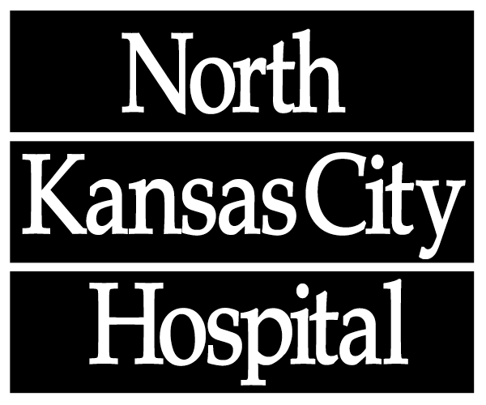

2800 Clay Edwards Drive
North Kansas City, MO
64116-3281

Dear Juniors and Seniors,

The North Kansas City Hospital (NKCH) Donor Council invites you to participate in our Annual Scholarship Opportunity.
Currently, more than 119,811 individuals nationwide are on the United Network of Organ Sharing recipient waiting list hoping for a life-saving organ. An average of 22 people die every day waiting for the gift of life. The NKCH Donor Council’s mission is to provide each potential donor family the opportunity to make an informed decision, to ensure that all potential donors are identified, to provide recipients life-saving organs and to provide professional and community education.
The following criteria must be met for the application process:
- Create a poster and request approval for it to be displayed at your school in the Month of April, National Organ Donation Month. Submit a picture of the poster to the NKCH Donor Council and notify the committee when it will be displayed.
- Write a 500 word essay explaining the theme of your poster and how you, as an individual, can raise awareness about Organ Donation in your community.
- The Donor Council will review all entries and pick the top two.
- Applications must be postmarked by January 220, 2017.
- By the first week of May 2017, we will select winners:
  - 1st place: $2,000
  - 2nd place: $1,000

Thank you for your interest in furthering donation efforts and increasing awareness in our community. For more information, contact Donor Council Members: Becky Hoffman at 816-691-5100 (becky.hoffman@nkch.org) or Dianne Studer at 816-691-5295 (dianne.studer@nkch.org).
Sincerely,

Becky Hoffman, BSN, RN, CEN Dianne Studer, RN, CCRN
Donor Council Chair Donor Council Member

