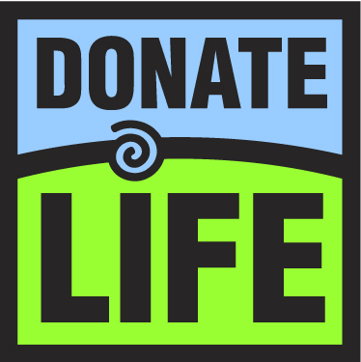**Scholarship**

**Opportunity**

**for Juniors**

**and Seniors!**

**--------------------------**

North Kansas City Hospital’s

Donate Life Committee is offering

**two scholarships** ($2,000 and $1,000) to Northland students who design a creative poster and write a short essay to increase awareness about organ and tissue donation.

**Entries are due January 20, 2017**

Ask your counselor for a

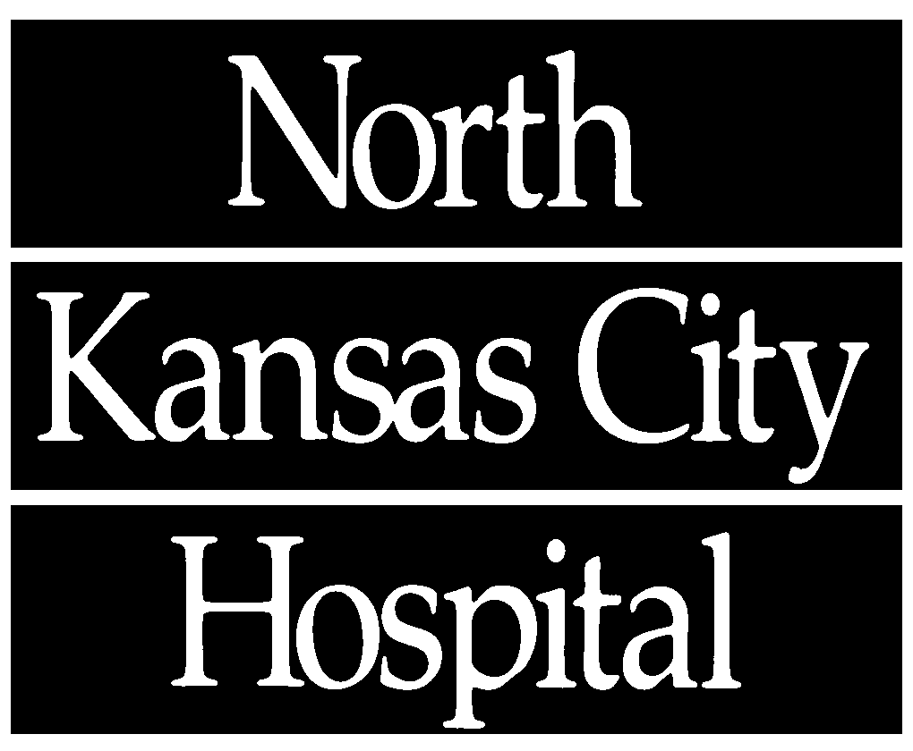

packet with full details.