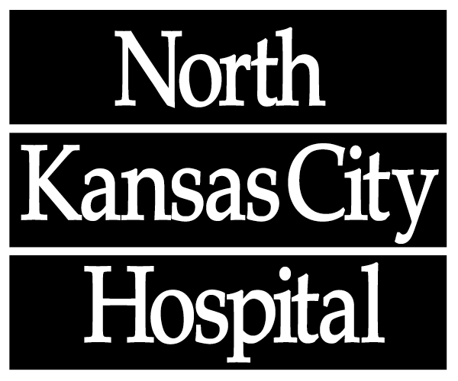

2800 Clay Edwards Drive
North Kansas City, MO
64116-3281

NKCH Donate Life Scholarship Entry Form

Requirements:
- Must be a junior or senior attending a Northland High School or a NKCH employee’s child who is a Junior or Senior .
- Design a poster to be displayed at school during National Organ Donation Awareness month in April. The theme of the poster must promote Organ Donation in our community. A picture of the poster must be submitted to the NKCH Donor Council with the dates it will be displayed prior to it being displayed.
- Write a 500 word essay explaining the theme of the poster and what you can do as an individual to promote Organ Donation.
- Two finalists will be chosen and receive scholarships: 1st place - $2,000 and 2nd place - $1,000.
- Entry deadline: postmarked by January 20, 2017 and submitted to:
North Kansas City Hospital
Sherry Billings, Emergency Department
2800 Clay Edwards Drive
North Kansas City, MO 64116-3281

Student’s Name: ____________________________________________________________

Home Address: ____________________________________________________________

____________________________________________________________

Phone Number: _________________________________SSN___________________________

School Name: ____________________________________________________________

School Counselor Name & Phone Number: _____________________________________

_____________________________________

