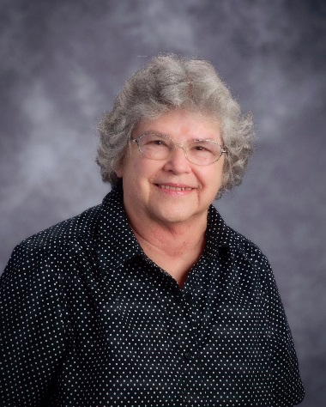
Jo Anne Baker
Memorial Scholarship
2016 Fact Sheet

Jo Anne Baker was an essential part of Oakwood Manor Elementary since its annexation by North Kansas City Schools in 1959. She opened the library, and it’s where her own children went to school. For 34 years, she served as an office clerk. She loved her job and the thousands of young people who attended school there over the decades. This memorial scholarship will be awarded to a graduate of North Kansas City Schools who is also a former student at Oakwood Manor.

Deadline Thursday, March 31, 2016

Amount One annual $500 scholarship

Eligibility
- You must have attended Oakwood Manor Elementary School and be a 2016 graduating senior from North Kansas City, Oak Park, Staley or Winnetonka High Schools.

- You must plan to pursue a post-secondary program of study at a two- or four-year institution.

- You must have maintained a GPA of 2.5 or higher during high school career.

- You must have performed at least 50 hours of community service during high school.

Required Documents
- Official Grade Transcript: Include your high school transcript showing you have achieved at least a 2.5 GPA.

- Community Service Form: Submit documentation showing that you have performed at least 50 hours of community service OR complete the attached form.

- Personal Essay: Write an essay of at least 250 words explaining the community service you performed during high school and how it has made an impact in life.

Process The Selection Committee will consist of Jo Anne Baker’s family members and Oakwood Manor staff members.

Payment The scholarship will be paid directly to the institution you plan to attend by the North Kansas City Schools Education Foundation, which holds the funds for the Jo Anne Baker Memorial Scholarship. If you do not complete a minimum of one semester, the funds must be returned to the Education Foundation so the first alternate may receive them.

Please submit the application form and all supporting materials in one envelope and mail or deliver to:
Jan Lewis, Director, North Kansas City Schools Education Foundation, 2000 N.E. 46th Street, Kansas City, MO, 64116. Applications must be postmarked or delivered by 5 p.m. on Thursday, March 31, 2016.

Jo Anne Baker Memorial Scholarship
2016 Application Form

Your Name: _____________________________________________ Date of Birth: ______________

Address: ___________________________________________________________________________

City: ______________________________________________ State: _________ Zip: _____________

Home Phone: __________________________________ Cell: _________________________________

Personal E-mail: ______________________________________________________________________

Years Attended Oakwood Manor Elementary School: ________________________________________

High School: ________________________________________________________________________

College Attending or Planning to Attend: __________________________________________________

Major Course of Study: ________________________________________________________________

Minor Course of Study: ________________________________________________________________

1st Parent/Legal Guardian: ______________________________________________________________

Address (if different from above):________________________________________________________

Place of Employment: ______________________________ Title: ______________________________

2nd Parent/Legal Guardian: _____________________________________________________________

Address (if different from above): ________________________________________________________

Place of Employment: _______________________________ Title: _____________________________

How are you financing your education? ____________________________________________________

____________________________________________________________________________________

ESSAY: On a separate sheet, submit a typewritten essay of at least 250 words explaining the community service you performed during high school and how it has impacted your life.

Your Signature: _______________________________________________ Date: ________________

Signature of Parent/Guardian: ___________________________________ Date: ________________

Please submit your application form and all supporting materials in one envelope and deliver or mail to:
Jan Lewis, North Kansas City Schools Education Foundation, 2000 N.E. 46th Street, Kansas City, MO 64116. Applications must be postmarked or delivered by 5 p.m. Thursday, March 31, 2016.
Jo Anne Baker Memorial Scholarship Community Service Form

Student Name: _____________________________________________________________________________
__________________________________________________________________________________________

Name of Service Agency or Organization: _______________________________________________________

Address: __________________________________________________________________________________

Supervisor/Title: ___________________________________________________________________________

Project Date(s): _____________________________________________ Total Volunteer Hours: ____________

Brief Description of Project: __________________________________________________________________

__________________________________________________________________________________________

__________________________________________________________________________________________

__________________________________________________________________________________________
__________________________________________________________________________________________

Name of Service Agency or Organization: _______________________________________________________

Address: __________________________________________________________________________________

Supervisor/Title: ___________________________________________________________________________

Project Date(s): _____________________________________________ Total Volunteer Hours: ____________

Brief Description of Project: __________________________________________________________________

__________________________________________________________________________________________

__________________________________________________________________________________________

__________________________________________________________________________________________

__________________________________________________________________________________________

Name of Service Agency or Organization: _______________________________________________________

Address: __________________________________________________________________________________

Supervisor/Title: ___________________________________________________________________________

Project Date(s): _____________________________________________ Total Volunteer Hours: ____________

Brief Description of Project: __________________________________________________________________

__________________________________________________________________________________________

__________________________________________________________________________________________

___________________________________________________________________________________

