Cummings Family Scholarship
2016 Fact Sheet

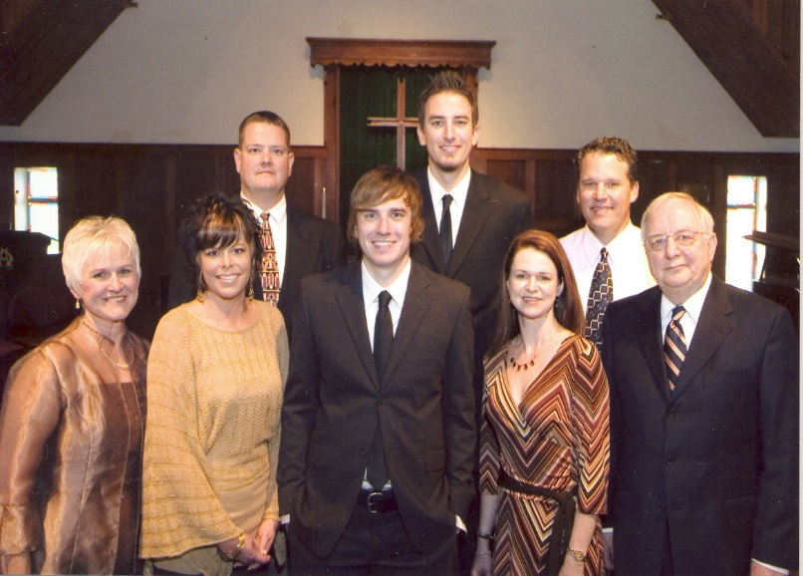
This scholarship was established by the family of Dr. Tom Cummings, North Kansas City Schools superintendent from 1995-2009. He also served as assistant superintendent for instruction for 10 years. During his tenure, the district earned national recognition for its cutting-edge curriculum, advanced degree programs, innovative technology and fine arts programs. Music has special meaning for the Cummings family. Sons Ben and Daniel were members of the Oak Park High School orchestra, and they played in many string quartets over the years. This scholarship will be awarded to a student who has been in orchestra.

Deadline Thursday, March 31, 2016

Amount One annual $500 scholarship

Eligibility
- A 2016 graduating senior in a North Kansas City School high school who has participated in orchestra for at least two years.
- Plans to pursue a post-secondary program of study in any field at a two- or four-year institution.
- A GPA of 3.0 or higher on a 4-point scale and 95% attendance record

Required Documents
- One-page essay stating how your time in orchestra has influenced your life and prepared you for success after high school
- Official grade transcript with ACT scores
- Official attendance record indicating 95% or better attendance
- Two letters of reference: one from your orchestra director and one from another teacher or influential person in your life
- List of school activities, out-of-school activities, leadership positions and community service

Process Members of the Cummings family will select the recipient.

Payment The scholarship will be paid directly to the institution you plan to attend. You must complete a minimum of one semester. If you withdraw before completing one semester, funds must be returned to the Education Foundation and the first alternate will receive the funds.

Please include the application form and all supporting materials in one envelope and mail or deliver to: Jan Lewis, Director, North Kansas City Schools Education Foundation, 2000 N.E. 46th Street, Kansas City, MO, 64116. Applications must be postmarked or delivered and received by 5 p.m. on Thursday, March 31, 2016.
Cummings Family Scholarship
2016 Application Form

Your Name: _____________________________________________ Date of Birth: ______________

Address: ___________________________________________________________________________

City: ______________________________________________ State: _________ Zip: _____________

Home Phone: __________________________________ Cell: _________________________________

Personal E-mail: ______________________________________________________________________

High School: ________________________________________________________________________

College Attending or Planning to Attend: __________________________________________________

Major Course of Study: ________________________________________________________________

Minor Course of Study: ________________________________________________________________

1st Parent/Legal Guardian: ______________________________________________________________

Address (if different from above):________________________________________________________

Place of Employment: ______________________________ Title: ______________________________

2nd Parent/Legal Guardian: _____________________________________________________________

Address (if different from above): ________________________________________________________

Place of Employment: _______________________________ Title: _____________________________

Who is financing your education? ________________________________________________________

____________________________________________________________________________________

List sources of financial aid: ____________________________________________________________

____________________________________________________________________________________

____________________________________________________________________________________

____________________________________________________________________________________

NOTE: You may attach extra sheets to provide the information below or recreate the form. Incomplete applications will NOT be considered. Please include all materials.

List your high school activities, including at least two years in your high school orchestra.

Describe your interests and activities outside of school, including hobbies, church activities and/or community interests (scouting, volunteering, etc.).

List any leadership positions you have held or special honors or recognitions you have received.

Provide a one-page essay stating how orchestra has influenced your life and prepared you for success after high school.

Your Signature: _______________________________________________ Date: ________________

Signature of Parent/Guardian: ___________________________________ Date: ________________

Please place your application form and all supporting materials in one envelope and deliver or mail to:

Jan Lewis
North Kansas City Schools Education Foundation
2000 N.E. 46th Street
Kansas City MO 64116

Applications must be postmarked or delivered and received by 5 p.m. Thursday, March 31, 2016.

